**ABSTRACT**

Shadow cause some unwanted change in computer vision and image analysis. Shadow leads to problems in extraction, segmentation of objects, and recognition due to the misclassification of shadow points as foreground or object points. So, the detection and removal of the shadow is of broad interest in computer vision. Due to the change in the illumination of the background and the similarity between the outlook of the objects and the background, shadow removal is difficult. Shadow removal is the overall performance enhancement method that will increase the accuracy of the Computer Vision algorithms like Object Tracking, Object Recognition, Image Segmentation, Surveillance, Scene Analysis, Stereo, etc.

**INTRODUCTION**

Shadow is a monocular cue in the human vision for depth and geometry perception. The presence of shadow, could deteriorate the performance of many fundamental computer vision tasks, such as object detection and tracking. Hence, shadow removal has long been a fundamental problem in computer vision.

Shadow appears as a surface feature and they cause by the interaction between object and light. Shadow leads to problems in the understanding of the scene, segmentation, object tracking, object identification, etc. On the other hand, shadow provides cues about object shape and light source. Shadow in the scene does not change the physical dimension of the object but it reduces the visibility of the surface/region where texture is present and also reduces the accuracy of recognition.

**OBJECTIVE**

The objective of this is to build a model which can detect and remove shadows from any given image and recreate the image after removing the image.

**FRAMEWORK**

A generative model was used as an approach. A generative model describes how a dataset is generated, in terms of a probabilistic model. By sampling from this model we are able to generate new data. Specifically, CycleGAN technique was used. The CycleGAN is a technique that involves the automatic training of image-to-image translation models without paired examples. The models are trained in an unsupervised manner using a collection of images from the source and target domain that do not need to be related in any way. So, the techniques that were used were, Convolutional Neural Network models as discriminator and a ResNet architecture for our generator, which is similar to a U-Net model in that it allows information from pervious layers in the network to skip ahead one or more layers with the help of residual blocks. By using this technique the model was able to transfer style of the non-shadowed images to the shadowed ones and create a non-shadowed image from a shadow image. The problem (end case situation), of the model receiving a non-shadowed image was by introducing a loss function during training so it doesn’t make any changes to the non-shadowed image.

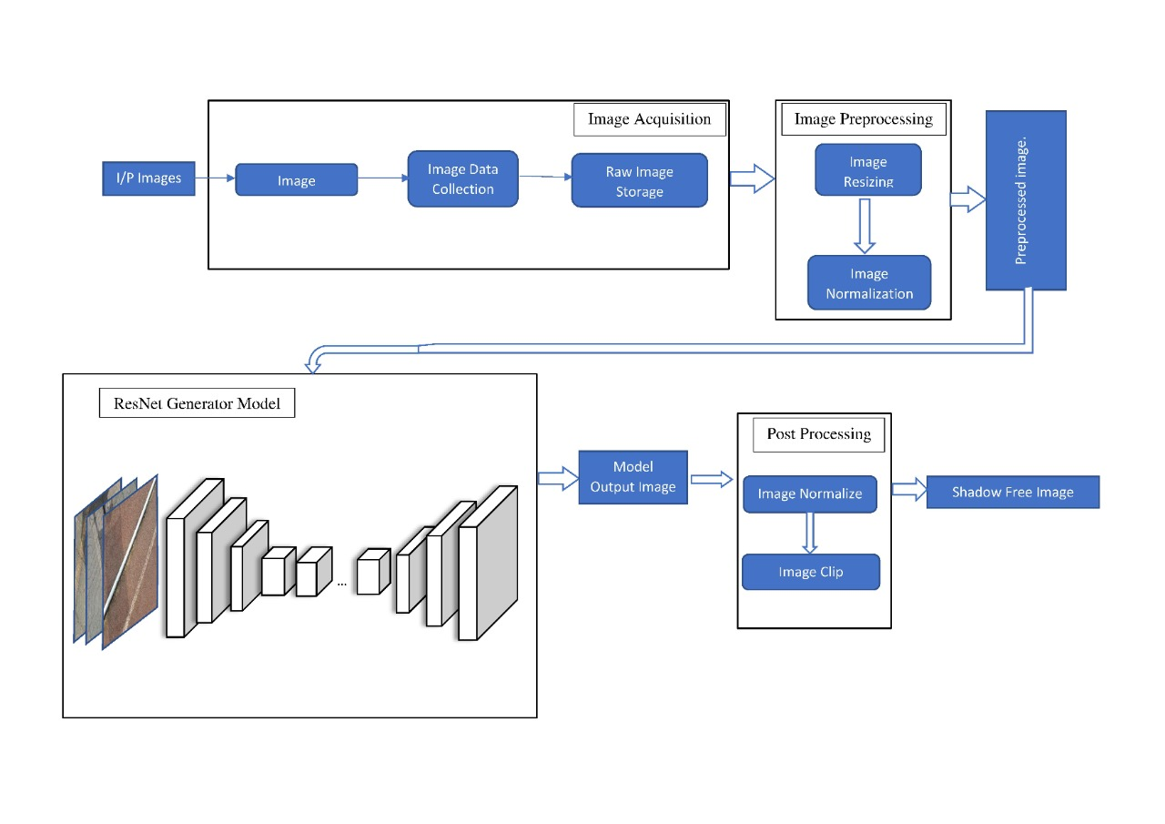

**RESULT**

An accuracy of 92% on testing data and 95% of training data has been achieved. Shadows formed over all kinds of surfaces (rough or smooth) can be removed. All shadows formed over different coloured. Two datasets were used for model building process which are the ISTD Dataset and the SBU Shadow dataset. The ISTD Dataset consisted of 1870 image and their respective shadow free pairs divided into training and testing data and the SBU Shadow dataset consisted of 4720 image and their respective shadow free pairs. From the results, it is concluded that even extremely small area shadows and shadows which are very dim have been detected and removed by the trained model.

The entire code can be found at:<https://drive.google.com/drive/folders/1ZFLHtTPTB4hM7W0VcqkpBepZYXyObamL>

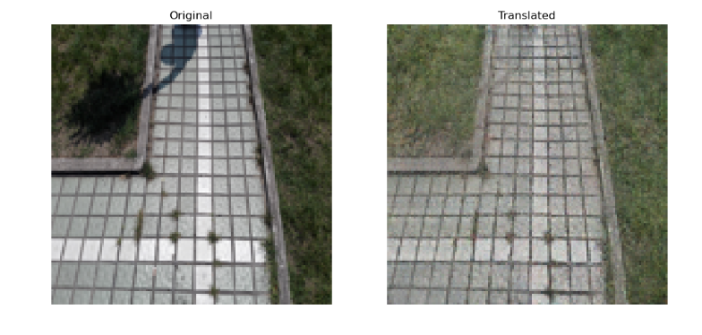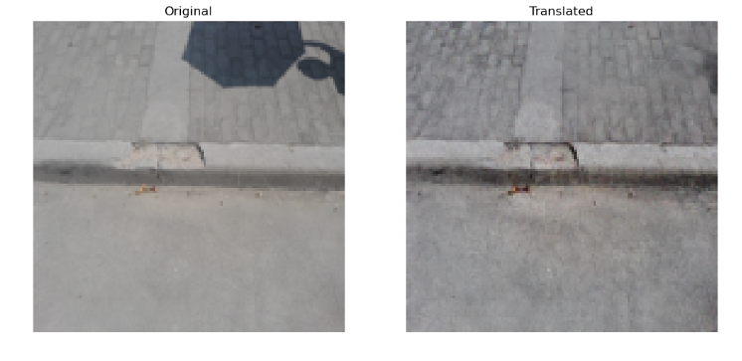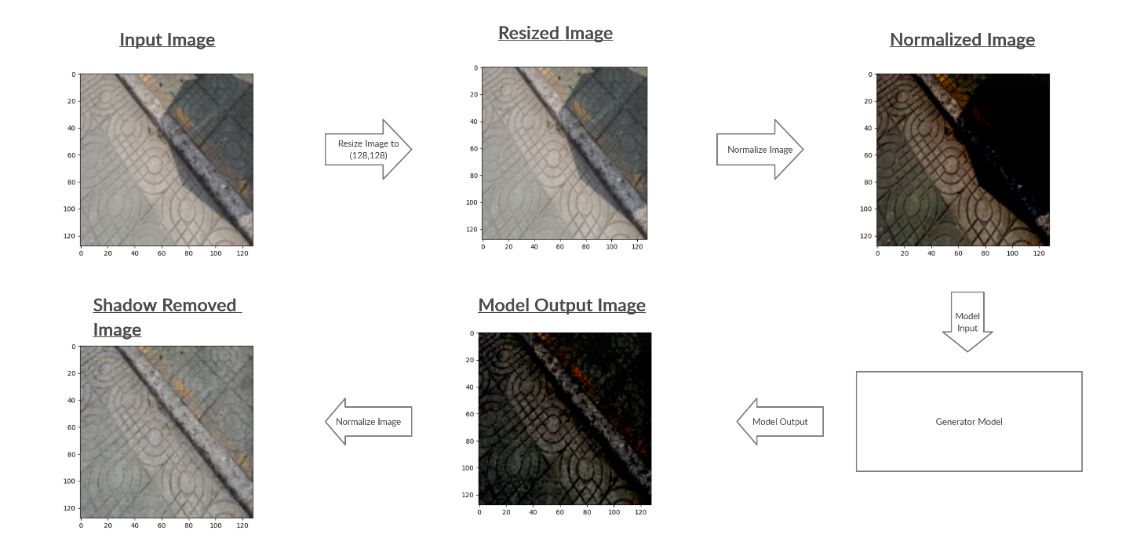

**TEAM MEMBERS**

1. Dr. Margret Anouncia S,
2. Dr. Mythili T
3. Bhavesh Goyal
4. Loukik Bhangale
5. Narayanasetty Swarag
6. Nitin Bhatia
7. Vivek Mathur